PATTERN RECOGNITION ALGORITHM TO DETECT SUSPICIOUS ACTIVITIES

Dr.Mahavishnu V C   
*Department of Computer Science and Engineering*

*PSG Institute of Technology and Applied Research*

Coimbatore, India

Vikhas S G   
*Department of Computer Science and Engineering*

*PSG Institute of Technology and Applied Research*

Coimbatore, India

Roopakumar S  
*Department of Computer Science and Engineering*

*PSG Institute of Technology and Applied Research*

Coimbatore, India

Shyamganesh T

*Department of Computer Science and Engineering*

*PSG Institute of Technology and Applied Research*

Coimbatore, India

Kavin S V  
*Department of Computer Science and Engineering*

*PSG Institute of Technology and Applied Research*

Coimbatore, India

***Abstract***— **Detecting suspicious activities in public places with higher people gathering and interaction has become an important task due to the increasing number of crime scenes and causalities happening in these days. Surveying and tracking of human activities are increasingly difficult owing to the random nature of human movements and actions. The reliability is greatly affected due to this randomness. Also a human operator cannot continuously monitor multiple screens efficiently in a consequent manner so an automated surveillance system deployment becomes a necessity. Currently, tracking civilians may be done remotely, and the analysis of the recorded photos can be automated using object detection models, with the help of high resolution cameras and the development of machine learning techniques.** **This proposed system aims in identifying threats that are probable to occur in a public gathering or space which may be an explosion, accident or possession of armoury et al. Our model takes advantage of the information from the pictorial data to learn complex patterns and develop pattern recognition technique to identify the anomalies using high resolution camera’s and alert the monitoring authority in order to take the necessary actions.** **This proposed work compares various object detection techniques of machine learning algorithms and suggests the best model based on its performance metrics.**

# ***Key Words*---** [**Suspicious Activity Monitoring**](https://www.mdpi.com/search?q=marine+animal+monitoring)**,**[**Anomaly Detection**](https://www.mdpi.com/search?q=anomaly+detection)**,** [**Deep Learning**](https://www.mdpi.com/search?q=deep+learning)**, Artificial Intelligence,**[**Convolutional Neural Networks**](https://www.mdpi.com/search?q=convolutional+neural+networks)**, Flask Web-Framework**.

# Introduction

A main concern of any governmental organization today for maintaining harmony within the society is providing proper safety and protection to an individual. The main reason behind these efforts and concerns are that due to the constantly increasing activities that pose as a major threats, starting from violent decisions taken as a factor of ferocity to a severe injury caused by an accident. Car accidents, sudden explosions, possession of weapons or any other arms pose as major threat to the civilian society. These actions do not fall under the regular day to day activities of a normal person and are against the norms of an organized society. Suspicious activity detection is the process of identifying patterns in actions or behaviors that are considered to be potentially harmful, illegal, or malicious to the society. It involves analyzing huge chunks of data from numerous sources, such as cctv footages, criminal records, or user behavior patterns, and by applying the required algorithms and machine learning techniques to recognize patterns and anomalies among the gathered data that may indicate suspicious activity.

Object detection has been facilitated by the use of low-cost public drones, cctv camera footages, computer vision, deep learning and a computational system that supports higher end graphics support. Computer vision can be subcategorized as a subset of Artificial Intelligence, which allows machines or systems to extract necessary and meaningful information and insights from data formats which include images or, videos or other formats of computer supported visual input and perform the necessary actions on that piece of data. Computer vision is like eyes for an automated intelligent system, which means that while AI makes it possible for the machine to think, computer vision makes it possible for machines to see and observe visual inputs. We can make use of these advancements made in these fields and them to support these detection tasks. Deep learning as a domain has witnessed tremendous growth owing to these facilitated developments in image processing, which paved way for availability of numerous popular frameworks which includes TensorFlow, Microsoft Cognitive Tool Kit et al.

Convolutional neural networks, the most widely used DL algorithms, have become the reference or go to point for image processing tasks that focus on object detection and segmentation. Tools like these are considered to be crucial for detection and analyzing purposes of the rapidly changing human activities in an image or video sequence. Computational requirements for training and hosting complex CNN networks, such as the faster regional convolutional neural network (Faster-RCNN), pose as a major challenge in many applications. These challenges have been relieved by advances in graphics processing units (GPU).The computer vision community now makes extensive use of GPUs, especially those who are interested in deep learning (DL) and speeding up model training and inference.

# LITERATURE SURVEY

Authors: Leela S, K V Sai Likhita, et al proposed that suspicious activity cause serious threaten to personal safety and identified Suspicious Human Activity Recognition and Alarming System. This system uses deep learning based CNN algorithm which has disadvantages that it requires lot of time. A CNN was used to extract spatial attributes at a certain time step in the input sequence (video), and an LSTM was utilized to detect temporal correlations between frames. Convolutional neural network models were developed for image classification tasks, and feature learning refers to the process through which the model learns an internal representation of a two-dimensional input. It has a 96% accuracy rating.

Suspicious Activity Detection System was proposed by Sumon et al. The Algorithm used in this system were Faster R-CNN and YOLOv3 technique. The main aim of this system is to automate video surveillance input images are not in proper way, different image preprocessing techniques are used in this system to enhance the quality of the image. The advantage of this paper is usage of faster CNN and sematic based approach in place of standard dataset unavailability. But , this system got accuracy of only 57%.

Monali Ahire, Devarshi Borse, et al CNN architecture to detect anomaly and suspicious activities. This paper proposes an intelligent system, which utilizes an expert video surveillance tool for monitoring of potentially suspicious and criminal activities in shopping malls. In this system, they have used HaarCascade method which is better for body detection but it is more complex in computational aspect. This system not only identify suspecious activity but also dangerous object with accuracy of nearly 92%.

This paper finds solution to one of the most important applications of human suspicious activity (anomaly) detection. It was proposed by Tejashri Subhash Bora1, Monika Dhananjay Rokade2. Inexpensive depth sensors have limitations such as limited indoor use, low resolution, and noisy depth.The information makes it difficult to estimate human pose from depth images. So they used neural networks to overcome these problems.

Detecting Anomalous Human Activity From Surveillance Video is an Active Investigation Part of image processing and computer visualization. The result of the proposed system can detect if any unusual actions occur or not. Also, most previous studies had poor accuracy in identifying abnormal behavior. Therefore, a new approach CNN is used here for better results.

Jefferson Ryan Medel, Andreas Savakis propose an end-to-end trainable complex convolutional long-short-term memory (Conv-LSTM) network for suspicious activity detection that can predict the evolution of video sequences from a small number of input frames.

This model uses composite structures and examines the effects of conditioning on learning more meaningful representations which is selected based on reconstruction and prediction accuracy.

The Conv-LSTM model has been evaluated qualitatively and quantitatively and has proven to be an effective tool for modeling and predicting video sequences.It is shown quantitative analysis that their model performs competitively with edge computing based anomaly detection methods on several datasets.

Advance Suspicious Activity Detection System was proposed by Ms Archana,R Ghuge et al. They suggested that the use of video monitoring for security purposes has become old. This paper executes two main function. First, it can detect and recognize faces, allowing us to trace suspects in criminals or people connected to them. Second, the network has been trained to spot suspicious activity. In this paper, they proposed a Deep Neural Network-based system that can classify suspicious activity and identify faces that can be trained to recognize suspects in criminal activity. This system uses the Convolutional Neural Network technique. This technique can be applied to any Real-Time implementation due to the significantly reduced processing time for each frame.

Digambar Kauthkar, et al proposed that an interesting topic of image processing and computer vision research is the detection of suspicious human activity and combat from video information. To train this system, deep learning and neural networks has been used. Applications for it in real life include gesture recognition, AR/VR, and gaming. The application of CNN in video classification is comparatively simple compared to the picture data domain.

In this model, they extract a more number of images from the video. Hence one disadvantage of ths system is if the video is large, creating frames will require more time.But, The advantage is that this model is suitable for CCTV images.

# DATASETS AND FEATURES

The dataset used in the proposed work comprises of images and live footages of suspicious activities that are scrapped off from the internet. This dataset has around 700 images that are classified under 6 classes of actions. The images are checked for any outliers and anomalies and removed manually to ensure efficient training of the model. The Image formats are loaded in png format and the size of the images are set at 256 x 256 to improve performance accuracy of the model. Resizing and rescaling will be done for the test data, for easy classification. Around 110 images are classified under each class to ensure equal distribution among the classes. The classes of activities used in this work are mentioned below:

* Fight or quarrel
* Explosion
* Road accidents
* Over crowding
* Weapon usage
* Animal Cruelty

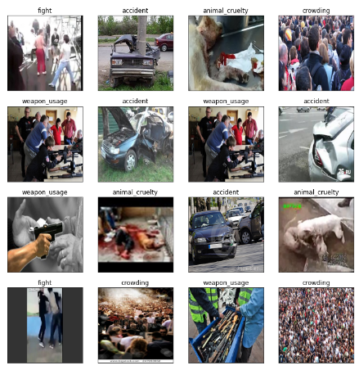

**Figure III‑1: Different Classes of Datasets**

# METHODOLOGIES

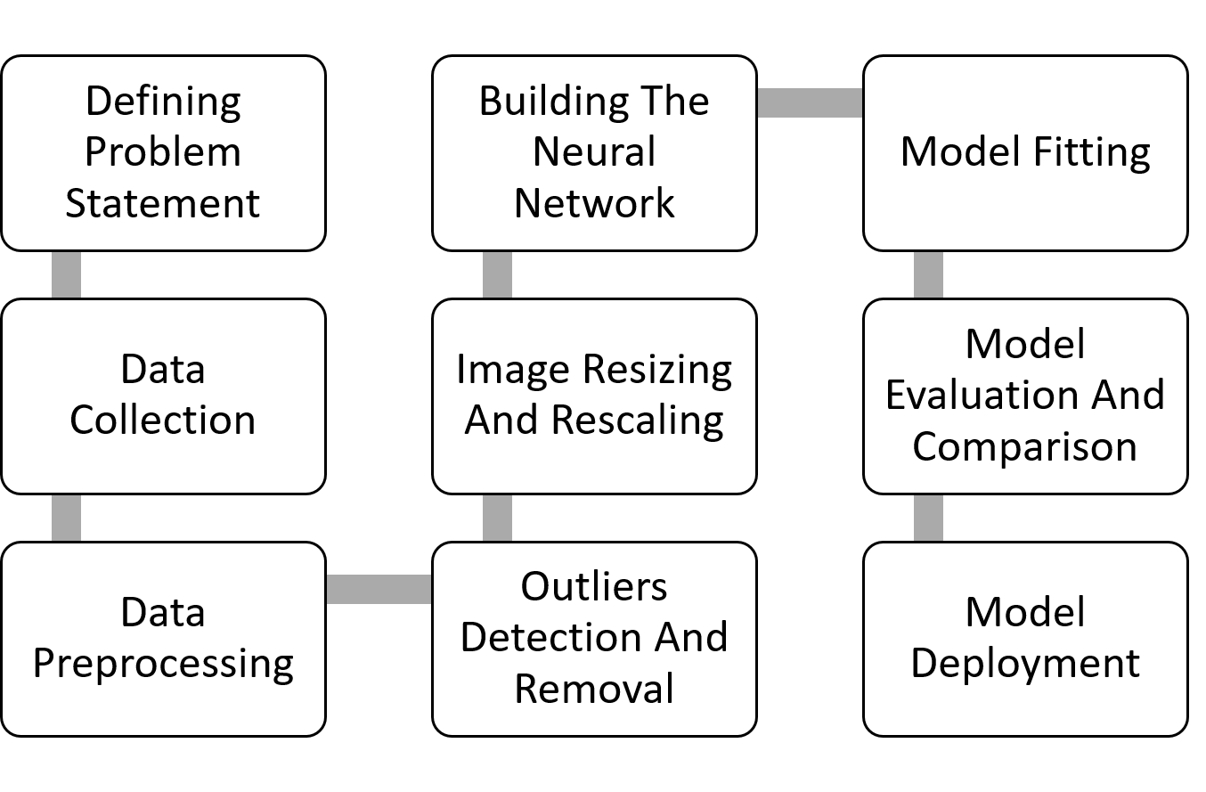

**Figure IV‑1: Workflow of model**

1. The problem statement is defined and the suitable data for the statement is searched.
2. The Dataset is scrapped from the internet and the dataset is classified under 6 classes, i.e. 6 activities of suspicion stored in six separate directories.
3. The dataset is clearly studied, and the preprocessing stages are undertaken.
4. Manually the dataset is analyzed and the images that are considered to be outliers are removed explicitly.
5. All the images are resized into a fixed size of 256 x 256 pixels.
6. The image format of all the images are converted to png, for training purposes.
7. The dataset is loaded, and the neural network is trained with the images.
8. 80% of the images are deployed for training, 10% for validation and 10% for testing purposes.
9. Convolutional layers and Pooling layers are used alternatively with 6 dense layers and ReLu function is used as an activation function in these layers.
10. Softmax activation function is used as an activation function in the output layer.
11. Adam optimizer is used for optimization purposes with accuracy as the metrics, and the model is trained for 50 epochs.
12. The accuracy of the model is measured.
13. The dataset is trained with Mobilenetv2 model with some additional optimizations for 50 epochs and the accuracy is measured.
14. The models are compared , and the model with better accuracy is chosen and deployed.

# PROPOSED MODEL

## **Web Scraping:**

The process of collecting and segregating necessary data from webpages through the internet is called web scraping. Several websites don't allow permissions for users to save data for personal use while they are browsing over the internet. Among many methods one of the popularly used archaic method is to manually copy and paste the data, which is time- and labor-intensive. Online scraping automates the process of data extraction from webpages.

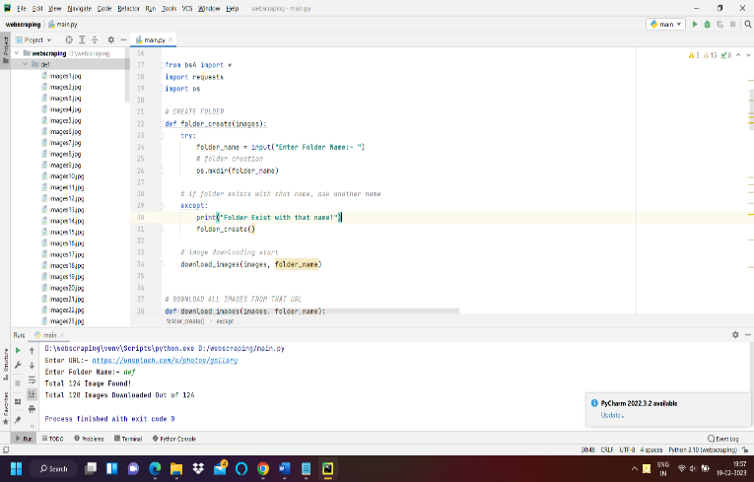

**Figure V‑1: Web Scraping Code**

Modules Needed:

BS4: Beautiful Soup is a Python based library for extraction of the required HTML and XML data files from the internet. It is not a built-in python module but can be imported easily when required for certain necessary purposes.

Requests: Requests allows the users to send HTTP/1.1 requests in a much easier way. This is not a built in module either but can be imported when required.

OS: The OS python module provides functionalities for user program and operating system interaction. OS is a standard Python utility module. By using this module OS dependent functionalities can be done in a much easier and portable way.

## **B. Mobilenet V1:**

MobileNetV1 is an exclusive type of convolutional neural network specifically designed for mobile and embedded vision-based applications. A depthwise separable convolutions are used for construction of an lightweight deep neural network that provides the user’s with low latency for mobile and embedded devices. The model outputs a globally pooled version of the last hidden state, which can be used in conjunction with a 7x7 average pooling layer.

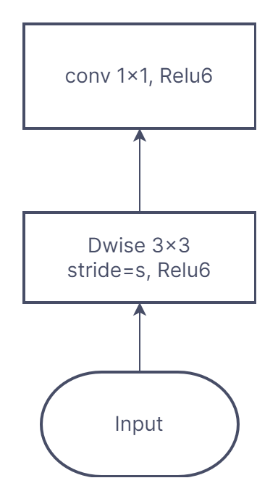

Figure V‑1: MobileNetV1 Convolutional Blocks

## **C. Mobilenet V2:**

MobileNetV2 is a CNN architecture developed by Google that is expected to give better performance on all mobile devices. The residual connections are made between the bottleneck layers in this inverted residual structure which forms the base architecture for this neural network. There are two basic blocks here, one of them being a stride one residual block and the remaining layers being three layers for both types of blocks. The basic idea behind Mobile Net v2 was to replace expensive convolutions with cheaper ones, making it more efficient choice than its predecessors.

|  |  |  |
| --- | --- | --- |
| **Input** | **Operator** | **Output** |
| h x w x k | 1x1 conv2d, ReLU6 | h x w x (tk) |
| h x w x tk | 3x3 dwise s=s, ReLU6 | h/s x w/s x (tk) |
| h/s x w/s x tk | Linear 1x1 conv2d | h/s x w/s x k’ |

In MobileNetV2 there are generally two blocks. Last block has a stride of one. The other is with a stride of two shrinking purposes .For both varieties of blocks, there exists three levels. The 1x1 convolution with ReLu6 forms the first layer.The depthwise convolutional layer forms the second layer.The third layer is a 1x1 convolution again, but here it lacks some non-linearity. Deep networks are assumed to have the power of a linear classifier alone on the output domain in the non zero volume portion if ReLU is deployed again and it is also noted that there is an expansion factor t. t=6 is set as standard for all main experiments. If the input has 64 channels, the internal output would get about 64×t=64×6=384 channels.

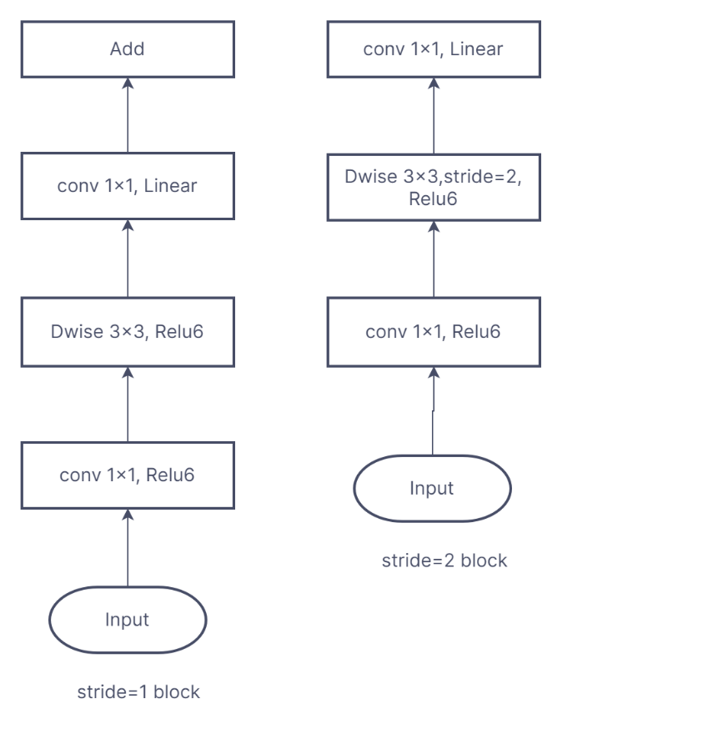Figure V‑2: MobileNetV2 Convolutional Blocks

## **D. Convolutional Neural Network Using TensorFlow – Keras**

In computer vision applications convolutional neural network, also stated to as CNN or convnets are a popular technique deployed usually. It is a class of deep neural networks that is generally deployed to evaluate visual data. This type of architecture is specifically used in a use case which includes recognizing objects from a picture or video . Modern day applications like image or video recognition , Neural language processing makes use of it.

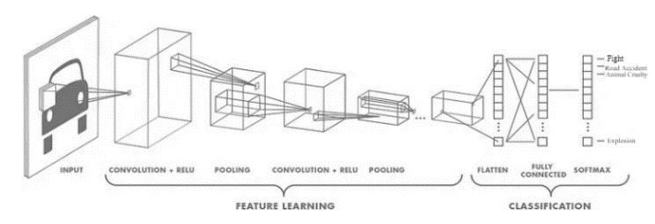

Figure V‑4: Keras model

Our convolutional neural networks task will be to categorize and identify images or certain entities in the image. Our features will be image data, and our label or output will be a label for those images. Many convolutional layers can be found intervened between other convolutional neural networks. Dense layers usually identify patterns in a better way globally while convolutional layers identify patterns locally. This is the key difference that distinct the two types of layers. Our convolutional layers receive feature maps as input and output a new feature map that replicates the presence of particular filters in the input feature map. We refer to these as response maps.

# RESULTS AND DISCUSSION

The figures depicts the accuracy and loss functions of the two models.Here is the table which includes the comparison of different models on the test data for the performance metrics.

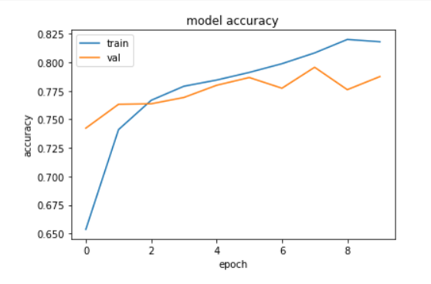

Figure VII‑1: Accuracy function for keras based CNN

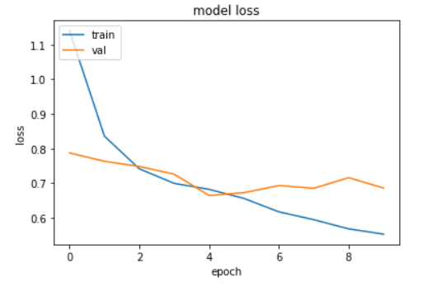

Figure VII‑2: Loss function for keras based CNN

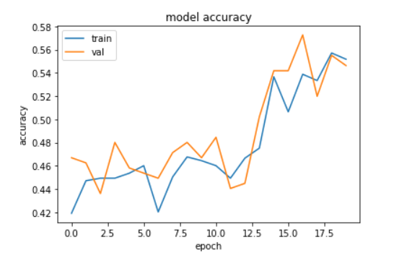

Figure VII‑3: Accuracy function for mobilenetV2 based CNN



Figure VII‑4: Loss function for mobilenetV2 based CNN

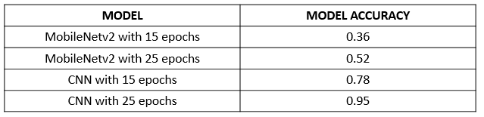

Figure VI‑5: Result of model

# CONCLUSION AND FUTURE WORK

Several civilian protection applications call for laborious and time-consuming procedures, such as watching video footage to look for activities that creates suspicion, looking for people initiating or committing a crime, and estimate for human population density. By deploying consumer-grade drones to gather data and transfer it to ML models for near-real-time picture analysis, the method presented in this research offers a potential tool to lessen the load of human routine activities in suspicious activity detection. Cellular networks or impromptu hotspots can be used to connect devices in the field to this.This will help to minimize crime rates in localities along with improvements in camera and drone technologies by enabling observation of civilians at considerably higher flight altitudes.

# REFERENCES

1)Dwivedi, N., Singh, D.K. & Kushwaha, D.S. A novel approach for suspicious activity detection with deep learning. Multimed Tools Appl (2023). https://doi.org/10.1007/s11042-023-14445-72)Gupta, A., Tickoo, A., Jindal, N., Shrivastava, A.K. (2023). Unusual Activity Detection Using Machine Learning. In: Mahapatra, R.P., Peddoju, S.K., Roy, S., Parwekar, P. (eds) Proceedings of International Conference on Recent Trends in Computing. Lecture Notes in Networks and Systems, vol 600. Springer, Singapore. https://doi.org/10.1007/978-981-19-8825-7_473)Bagane, P., Krishna, K.H., Beram, S.M., Purohit, P., Gayathri, B. (2023). Unsupervised Machine Learning for Unusual Crowd Activity Detection. In: Mahapatra, R.P., Peddoju, S.K., Roy, S., Parwekar, P. (eds) Proceedings of International Conference on Recent Trends in Computing. Lecture Notes in Networks and Systems, vol 600. Springer, Singapore. https://doi.org/10.1007/978-981-19-8825-7_704)Dhanush Kumar, A., Shushruth Reddy, P., Parikh, K.C., Meghana Sarvani, C., Loel Maansi, P. (2022). Abnormal Activity Detection Using Deep Learning. In: Nagar, A.K., Jat, D.S., Marín-Raventós, G., Mishra, D.K. (eds) Intelligent Sustainable Systems. Lecture Notes in Networks and Systems, vol 333. Springer, Singapore. https://doi.org/10.1007/978-981-16-6309-3_635)Sharma, M., Garg, D.K. (2022). Human Activity Detection-Based Upon CNN with Pruning and Edge Detection. In: Mohanty, M.N., Das, S. (eds) Advances in Intelligent Computing and Communication. Lecture Notes in Networks and Systems, vol 430. Springer, Singapore. https://doi.org/10.1007/978-981-19-0825-5_26)Prabha, B., Manivannan, P., Nagesh, P. (2022). Human Abnormal Activity Detection in the ATM Surveillance Video. In: Chowdary, P.S.R., Anguera, J., Satapathy, S.C., Bhateja, V. (eds) Evolution in Signal Processing and Telecommunication Networks. Lecture Notes in Electrical Engineering, vol 839. Springer, Singapore. https://doi.org/10.1007/978-981-16-8554-5_57)Visuwasam, L.M.M., Kalpana, G., Dhinakaran, K., Kumar, N.K., Manigandan, V. (2022). Implementation of Unusual Human Activity Detection in Warehouse Using SSD. In: Kumar, A., Ghinea, G., Merugu, S., Hashimoto, T. (eds) Proceedings of the International Conference on Cognitive and Intelligent Computing. Cognitive Science and Technology. Springer, Singapore. https://doi.org/10.1007/978-981-19-2350-0_808)Agarwal, M., Parashar, P., Mathur, A., Utkarsh, K., Sinha, A. (2022). Suspicious Activity Detection in Surveillance Applications Using Slow-Fast Convolutional Neural Network. In: Verma, P., Charan, C., Fernando, X., Ganesan, S. (eds) Advances in Data Computing, Communication and Security. Lecture Notes on Data Engineering and Communications Technologies, vol 106. Springer, Singapore. https://doi.org/10.1007/978-981-16-8403-6_599)de Oliveira, W.G., Filho, P.P.R., da Silva Junior, E.T. (2022). Driver Behavior Analysis: Abnormal Driving Detection Using MLP Classifier Applied to Outdoor Camera Images. In: Abraham, A., Gandhi, N., Hanne, T., Hong, TP., Nogueira Rios, T., Ding, W. (eds) Intelligent Systems Design and Applications. ISDA 2021. Lecture Notes in Networks and Systems, vol 418. Springer, Cham. https://doi.org/10.1007/978-3-030-96308-8_10610)Kaur, G., Singh, S. (2022). Violence Detection in Videos Using Deep Learning: A Survey. In: Goar, V., Kuri, M., Kumar, R., Senjyu, T. (eds) Advances in Information Communication Technology and Computing. Lecture Notes in Networks and Systems, vol 392. Springer, Singapore. https://doi.org/10.1007/978-981-19-0619-0_1511)Pawade, A., Anjaria, R., Satpute, V.R. (2021). Suspicious Activity Detection for Security Cameras. In: Kumar, R., Dohare, R.K., Dubey, H., Singh, V.P. (eds) Applications of Advanced Computing in Systems. Algorithms for Intelligent Systems. Springer, Singapore. https://doi.org/10.1007/978-981-33-4862-2_2212)Thombare, P., Gond, V., Satpute, V.R. (2021). Artificial Intelligence for Low Level Suspicious Activity Detection. In: Kumar, R., Dohare, R.K., Dubey, H., Singh, V.P. (eds) Applications of Advanced Computing in Systems. Algorithms for Intelligent Systems. Springer, Singapore. https://doi.org/10.1007/978-981-33-4862-2_2313)Pawar, K., Attar, V. (2021). Automated Surveillance Model for Video-Based Anomalous Activity Detection Using Deep Learning Architecture. In: Sharma, M.K., Dhaka, V.S., Perumal, T., Dey, N., Tavares, J.M.R.S. (eds) Innovations in Computational Intelligence and Computer Vision. Advances in Intelligent Systems and Computing, vol 1189. Springer, Singapore. https://doi.org/10.1007/978-981-15-6067-5_3614)Saidon, M.S., Mustafa, W.A., Rajasalavam, V.R., Khairunizam, W. (2021). Automatic People Counting System Using Aerial Image Captured by Drone for Event Management. In: Bahari, M.S., Harun, A., Zainal Abidin, Z., Hamidon, R., Zakaria, S. (eds) Intelligent Manufacturing and Mechatronics. Lecture Notes in Mechanical Engineering. Springer, Singapore. https://doi.org/10.1007/978-981-16-0866-7_415)Vallathan, G., John, A., Thirumalai, C. et al. Suspicious activity detection using deep learning in secure assisted living IoT environments. J Supercomput 77, 3242–3260 (2021). https://doi.org/10.1007/s11227-020-03387-816)Gorave, A., Misra, S., Padir, O., Patil, A., Ladole, K. (2020). Suspicious Activity Detection Using Live Video Analysis. In: Bhalla, S., Kwan, P., Bedekar, M., Phalnikar, R., Sirsikar, S. (eds) Proceeding of International Conference on Computational Science and Applications. Algorithms for Intelligent Systems. Springer, Singapore. https://doi.org/10.1007/978-981-15-0790-8_2117)Castellano, G., Castiello, C., Cianciotta, M., Mencar, C., Vessio, G. (2020). Multi-view Convolutional Network for Crowd Counting in Drone-Captured Images. In: Bartoli, A., Fusiello, A. (eds) Computer Vision – ECCV 2020 Workshops. ECCV 2020. Lecture Notes in Computer Science(), vol 12538. Springer, Cham. https://doi.org/10.1007/978-3-030-66823-5_3518)Iqbal, N., Saad Missen, M.M., Salamat, N., Prasath, V.B.S. (2019). On Video Based Human Abnormal Activity Detection with Histogram of Oriented Gradients. In: Singh, A., Mohan, A. (eds) Handbook of Multimedia Information Security: Techniques and Applications. Springer, Cham. https://doi.org/10.1007/978-3-030-15887-3_2119)Kalech, M., Shlomo, A., Moskovich, R. (2019). Temporal Pattern-Based Malicious Activity Detection in SCADA Systems (Brief Announcement). In: Dolev, S., Hendler, D., Lodha, S., Yung, M. (eds) Cyber Security Cryptography and Machine Learning. CSCML 2019. Lecture Notes in Computer Science(), vol 11527. Springer, Cham. https://doi.org/10.1007/978-3-030-20951-3_2620)Fraś, M., Bednarz, M. (2017). Simple Rule-Based Human Activity Detection with Use of Mobile Phone Sensors. In: Grzech, A., Świątek, J., Wilimowska, Z., Borzemski, L. (eds) Information Systems Architecture and Technology: Proceedings of 37th International Conference on Information Systems Architecture and Technology – ISAT 2016 – Part II. Advances in Intelligent Systems and Computing, vol 522. Springer, Cham. https://doi.org/10.1007/978-3-319-46586-9_421)Senthilkumar, T., Narmatha, G. (2016). Suspicious Human Activity Detection in Classroom Examination. In: Senthilkumar, M., Ramasamy, V., Sheen, S., Veeramani, C., Bonato, A., Batten, L. (eds) Computational Intelligence, Cyber Security and Computational Models. Advances in Intelligent Systems and Computing, vol 412. Springer, Singapore. https://doi.org/10.1007/978-981-10-0251-9_1122)Shin, H., Choi, K., Park, Y., Choi, J., Kim, Y. (2016). Security Analysis of FHSS-type Drone Controller. In: Kim, Hw., Choi, D. (eds) Information Security Applications. WISA 2015. Lecture Notes in Computer Science(), vol 9503. Springer, Cham. https://doi.org/10.1007/978-3-319-31875-2_2023)Zhao, Y., Qiao, Y., Yang, J., Kasabov, N. (2015). Abnormal Activity Detection Using Spatio-Temporal Feature and Laplacian Sparse Representation. In: Arik, S., Huang, T., Lai, W., Liu, Q. (eds) Neural Information Processing. ICONIP 2015. Lecture Notes in Computer Science(), vol 9492. Springer, Cham. https://doi.org/10.1007/978-3-319-26561-2_4924)Yussiff, AL., Yong, SP., Baharudin, B.B. (2014). Detecting People Using Histogram of Oriented Gradients: A Step towards Abnormal Human Activity Detection. In: Jeong, H., S. Obaidat, M., Yen, N., Park, J. (eds) Advances in Computer Science and its Applications. Lecture Notes in Electrical Engineering, vol 279. Springer, Berlin, Heidelberg. https://doi.org/10.1007/978-3-642-41674-3_15925)Dimoulas, C.A., Avdelidis, K.A., Kalliris, G.M. et al. Joint Wavelet Video Denoising and Motion Activity Detection in Multimodal Human Activity Analysis: Application to Video-Assisted Bioacoustic/Psychophysiological Monitoring. EURASIP J. Adv. Signal Process. 2008, 792028 (2007). https://doi.org/10.1155/2008/792028